Category Overview
22:03:39
Mayıs 11, 2006
IE 306 HW 7
Time Units:
Replications:
200
Hours
Values Across All Replications
User Specified
Counter
Count
Maximum
Average
Minimum
Average
Half Width
Average
70.5600
Customers Satisfied
< 0,77
75.0000
52.0000
2.5750
Lost Customers
< 0,68
38.0000
0.00
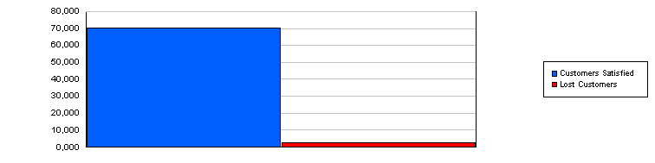
Time Persistent
Variable
Maximum
Average
Minimum
Average
Half Width
Average
Minimum
Value
Maximum
Value
3.1675
Hotdog
< 0,04
1.9427
3.4806
0.00
4.0000
33.5234
Raw Material
< 0,60
22.8833
48.2359
0.00
75.0000

Average daily total cost (holding + lost sales) and the maximum daily total cost are calculated in the excel file 43_Average_Costs.xls. The results are given here:

Confidence interval: 46.18372 < X < 46.61304
Maximum Daily Total Cost: 212.8833

Confidence interval for maximum daily total cost: 85.33762 < max < 92.70494

Emin Şenay

